Department of Technical Education
Capstone project
Work Breakdown Structure

Capstone Project Name:
Segmentation of Arecaunt Bunches Using Deep Learning

Capstone Project Members:
- Bhoomika
- Divya shivayogi chouter
- Sanjana

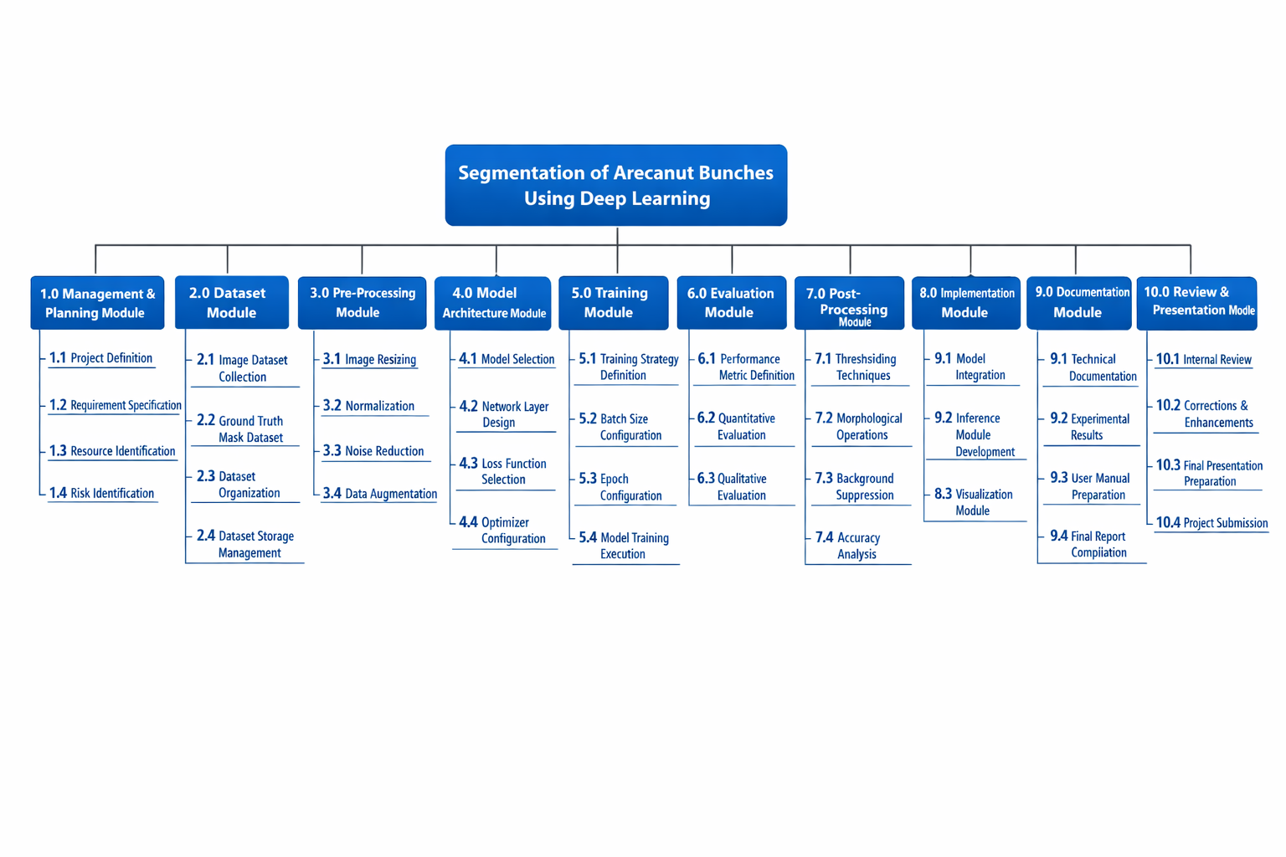

1. Management & Planning Module
- Includes tasks like Project Definition, Requirement Specification, Resource Identification, and Risk Identification.
- Covers all planning and coordination activities.
2. Dataset Module
- Covers Image Dataset Collection, Ground Truth Mask Dataset, Dataset Organization, and Storage Management.
- Ensures all images and masks are ready, organized, and stored for processing.
3. Pre-Processing Module
- Tasks: Image Resizing, Normalization, Noise Reduction, and Data Augmentation.
- Prepares the dataset for efficient training and accurate segmentation.
4. Model Architecture Module
- Includes Model Selection, Network Layer Design, Loss Function Selection, Optimizer Configuration.
- Defines the deep learning model structure and settings.
5. Training Module
- Covers Training Strategy Definition, Batch Size, Epoch Configuration, and Model Training Execution.
- Responsible for training the model on the dataset.
6. Evaluation Module
- Tasks: Performance Metric Definition, Quantitative Evaluation, Qualitative Evaluation.
- Evaluates the model accuracy, precision, and visual performance.
7. Post-Processing Module
- Tasks: Thresholding Techniques, Morphological Operations, Background Suppression, Accuracy Analysis.
- Ensures cleaned and usable segmentation output.
8. Implementation Module
- Model Integration, Inference Module Development, Visualization Module.
- Implements the trained model for actual use and display.
9. Documentation Module
- Technical Documentation, Experimental Results, User Manual, Final Report Compilation.
- Covers all reporting and documentation for the project.
10. Review & Presentation Module
- Internal Review, Corrections & Enhancements, Final Presentation Preparation, Project Submission.
- Ensures final checking, improvements, and submission.

Date:

Signature of the Student:
Signature of the Cohort Owner:

